**HTML Fundamentals**

**Problem 1. Runners Home page**

* Write an HTML page like the following:

*Note: use headings, divs, paragraphs and ul*

[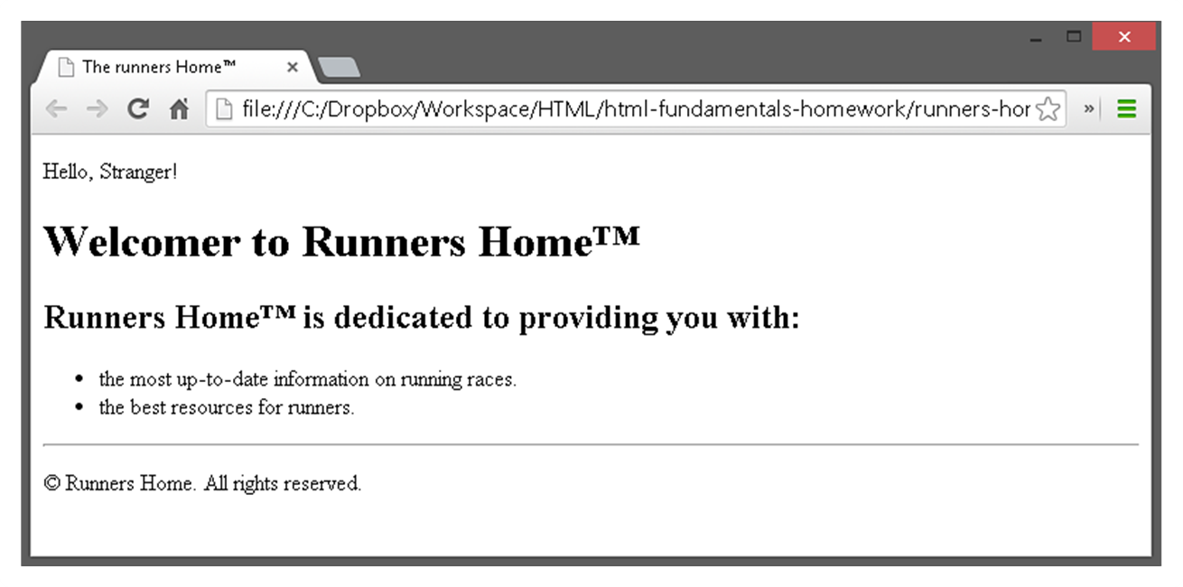](https://cloud.githubusercontent.com/assets/3619393/7002604/e4dadf2a-dc55-11e4-9743-76f4cf0c3f5b.png)

**Problem 2. Nested Lists**

* Write an HTML page like the following:

[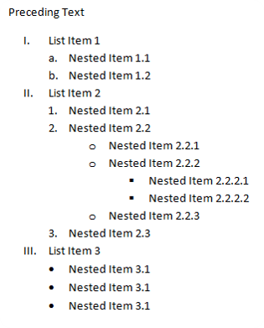](https://cloud.githubusercontent.com/assets/3619393/7002607/ee1e65c0-dc55-11e4-966e-2eb85ea38c0d.png)

**Problem 3. Social site**

* Create an user profile Web page profile.html, friends page named friends.html and info page named home.html.
* Link them to one another using <a> tag

[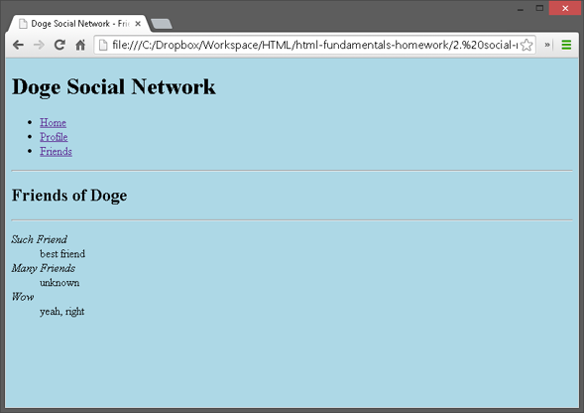](https://cloud.githubusercontent.com/assets/3619393/7002582/b53708fc-dc55-11e4-88f9-831a63a7a6c0.png)

[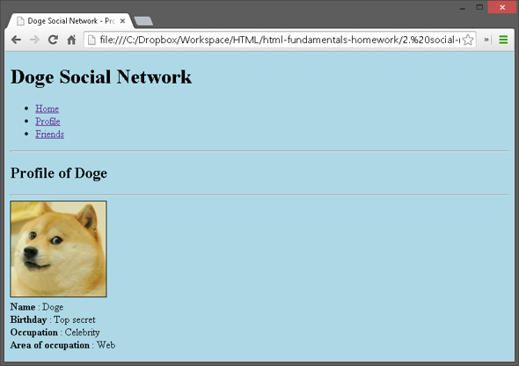](https://cloud.githubusercontent.com/assets/3619393/7002592/c14ee27c-dc55-11e4-85c5-42fefe9f9751.png)

[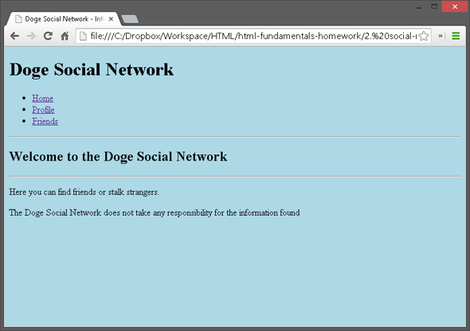](https://cloud.githubusercontent.com/assets/3619393/7002594/c9f92266-dc55-11e4-8396-f5ac08234561.png)